

**TASK – 1**

**YouTube Streamer Analysis:**

Description: This dataset contains valuable information about the top YouTube streamers, including their ranking, categories, subscribers, country, visits, likes, comments, and more. Your task is to perform a comprehensive analysis of the dataset to extract insights about the top YouTube content creators.

**1. Data Exploration:**

The dataset contains 8 columns with 1001 rows with key variables.

The key variables are

* Categories
* Subscribers
* Country
* Visits
* Likes
* Comments

**2. Trend Analysis:**

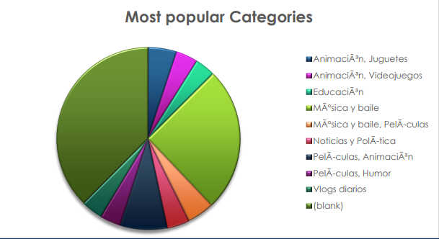

**3. Audience Study:**

The distribution of streamers audiences by country is analysed. The regional preferences for specific content categories

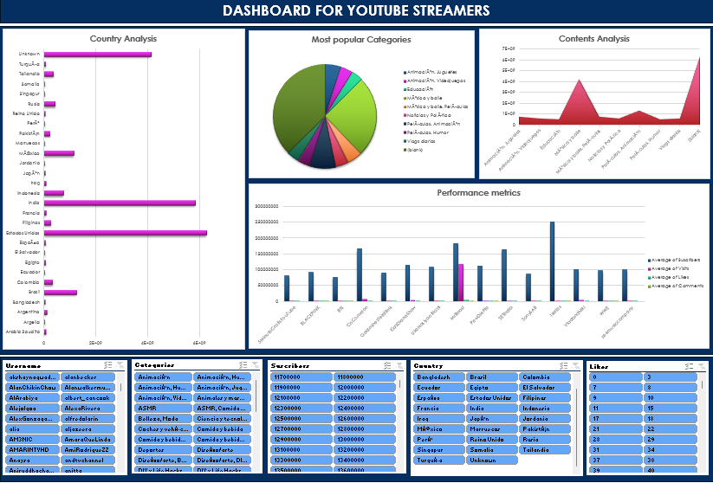

**4. Performance Metrics:**

The calculated average number of subscribers, visits, likes, and comments.

|  |  |  |  |  |
| --- | --- | --- | --- | --- |
| **Username** | **Average of Suscribers** | **Average of Visits** | **Average of Likes** | **Average of Comments** |
| 5MinuteCraftsYouTube | 80300000 | 164600 | 703 | 35 |
| BLACKPINK | 91300000 | 863200 | 146900 | 3400 |
| BTS | 76500000 | 969700 | 180300 | 7400 |
| CoComelon | 165500000 | 7000000 | 24700 | 0 |
| GoldminesTelefilms | 89700000 | 34600 | 421 | 13 |
| KidsDianaShow | 113500000 | 3900000 | 12400 | 0 |
| LikeNastyaofficial | 107500000 | 2600000 | 28000 | 0 |
| MrBeast | 183500000 | 117400000 | 5300000 | 18500 |
| PewDiePie | 111500000 | 2400000 | 197300 | 4900 |
| **Grand Total** | **121006666.7** | **9321880** | **395013.6667** | **2306.8** |

**5. Content Categories:**

* Videojuegos, Humor with 174074500 streamers

|  |  |
| --- | --- |
| **Categories** | **Sum of Suscribers** |
| AnimaciÃ³n, Juguetes | 851900000 |
| AnimaciÃ³n, Videojuegos | 659400000 |
| EducaciÃ³n | 600300000 |
| MÃºsica y baile | 4293900000 |
| MÃºsica y baile, PelÃ­culas | 798500000 |
| Noticias y PolÃ­tica | 676100000 |
| PelÃ­culas, AnimaciÃ³n | 1384300000 |
| PelÃ­culas, Humor | 622100000 |
| Vlogs diarios | 654900000 |
| (blank) | 6338000000 |
| **Grand Total** | **16879400000** |

**6. Brands and Collaborations:**

Yes, streamers with high performance metrics receive more brand collaborations and marketing campaigns.

**7. Benchmarking:**

Identified streamers with above-average performance in terms of subscribers, visits, likes, and comments.

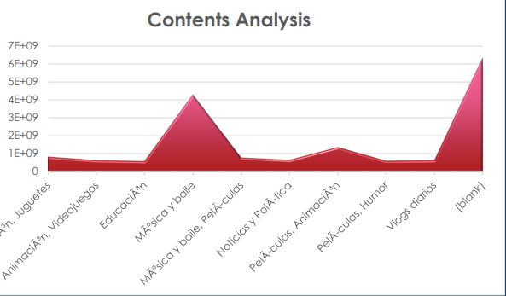

**8. Content Recommendations:**

* Develop targeted content strategies that cater to specific audience segments and regional preferences.
* Optimize performance by identifying and emulating successful content creation strategies.
* Enhance content recommendations for users, leading to improved engagement and satisfaction.
* Attract brands and collaborations by demonstrating strong performance metrics and audience reach.

DASHBOARD

